Sport & Exercise Science NEW ZEALAND

Annual Conference
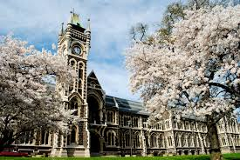
Dates
26th-27th October 2018

Location

University of Otago
Dunedin, New Zealand

Conference Themes
High Performance Sport Clinical Exercise Science Sports Nutrition

Keynote Speakers
Professor John Hawley is world-renowned exercise physiologist and sports nutritionist with a focus on the interaction of exercise and diet on the regulation of fat and carbohydrate metabolism and is a consultant for numerous professional sports across Europe and Australia.
Professor Kathryn Schmitz is Professor of Epidemiology at Penn State University College of Medicine and chair of ACSM’s Planning Committee Roundtable on Exercise and Cancer guidelines.
Professor Glenn McConell is an international expert on the regulation of skeletal muscle glucose uptake during exercise and is on the Editorial board of the Journal of Applied physiology.
Dr Shona Halson is the Senior Recovery Physiologist at the Australian Institute of Sport and an Associate Editor of the International Journal of Sports Physiology and Performance. ‬‬‬‬‬
Professor Rachael Taylor is Director of the Edgar Diabetes and Obesity Research Centre, and theme leader within A Better Start - National Science Challenge.
Associate Professor Debra Waters is the Director of Gerontology Research at Otago University and the Deputy Director of the Ageing Well NSC.
Dr Keith Tolfrey is the Chair of the British Association of Sport and Exercise Sciences (BASES).

Hosted by
The School of Physical Education, Sport and Exercise Sciences and the Department of Human Nutrition, University of Otago.
To Register visit www.sesnz.org.nz

